**ECE 3027 Electronics Laboratory – Lab 6**

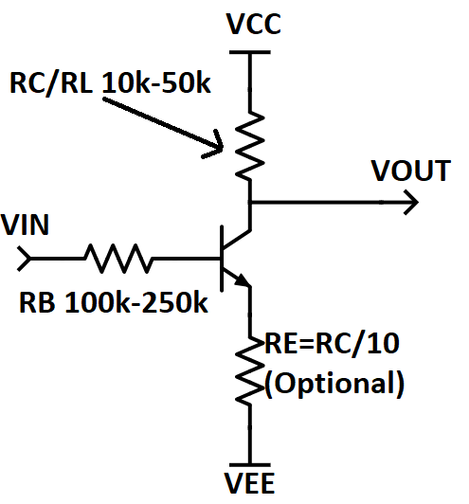**Transistor Basics:**

**Figure 1** is the schematic for the NPN-based Common Emitter amplifier. BJT operates as an amplifier in **Active Region**.

For the BJT to turn on, VBE (voltage between the base and emitter) should be roughly 0.7V. (Voltage drop across diode)

For a PNP, assuming Re is left out, VE is at the top rail instead of the bottom rail, so VEB will have this same voltage.

Figure 1

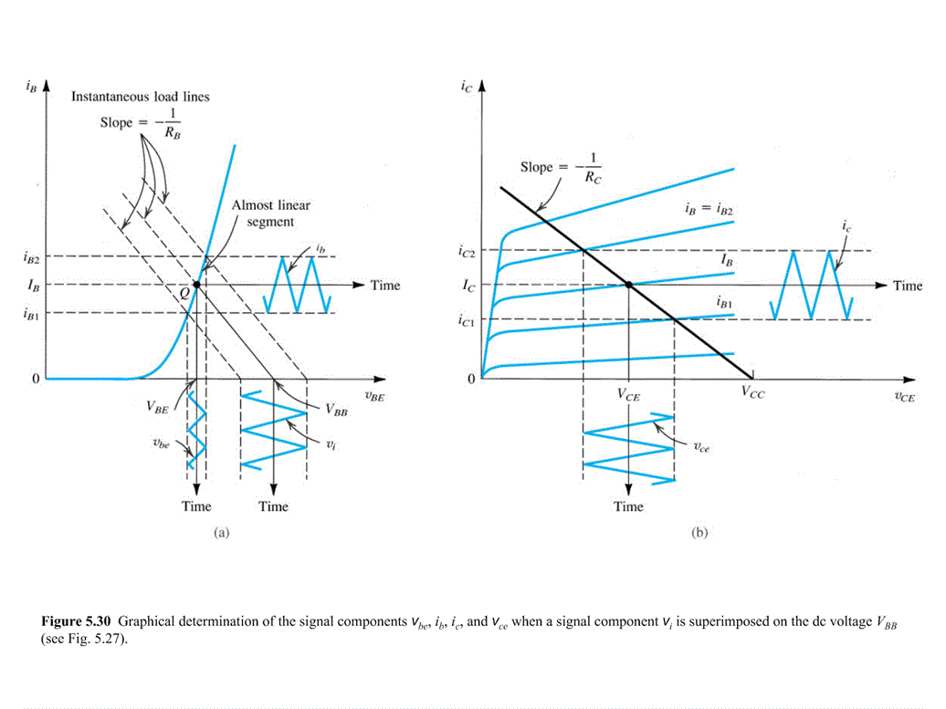**Transistor for Amplification:**

A transistor-based (or diode-based) amplifier operates since a small enough slice of its DC transfer curve will be mostly linear.

For an NPN, a small enough slice will mean that a DC voltage at VBE will translate almost linearly to the base current Ib. The collector current Ic is directly proportional to Ib, and Vo is directly proportional to Ic because Vo=Ic*Rc and Rc stays constant. Hence, Vo is, mostly, directly proportional to Vbe, and thus, this circuit can linearly amplify an AC voltage that stays within this slice.

Figure 2

**Figure 2** (taken from Sedra Smith) indicates that this slice exists somewhere close to the voltage required to turn on the transistor. A small AC voltage that stays within this slice is what is being amplified. Hence, the “operating point”, or “Q point”, is a DC voltage, which is not linearly amplified, and has to be provided as a DC bias that the AC voltage, which *is* being linearly amplified, rides *on top of*. “VBB” on the graph is the operating point that comes about when the base resistor Rb is added, showing that the amplifier sensitivity decreases due to this resistor, which makes it easier to use, and protects the transistor. This circuit is useful for taking any weak periodic signal (say an audio signal from a microphone) and strengthening it (to drive a speaker, for example). In such a circuit, the DC bias can easily be added to the input using an op-amp-based amplifier that is referenced to the Q point instead of ground, the AC voltage can be amplified through the circuit, and the half-rail bias on the output can be removed by a high-pass filter.

**Alternative Viewpoint Two Diodes:**

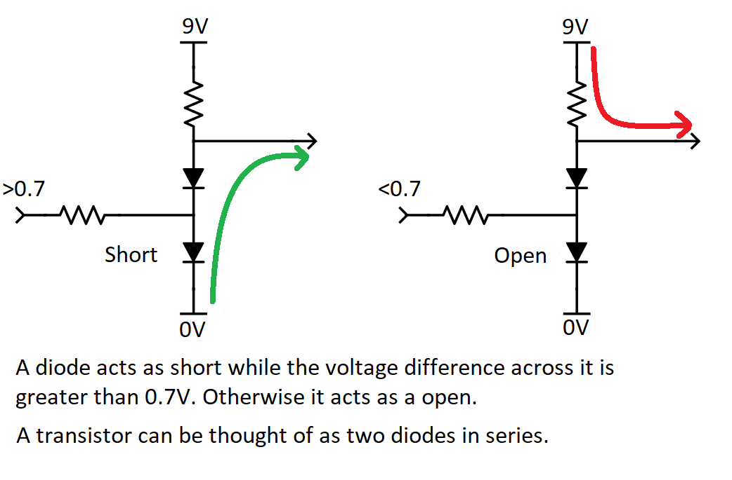

**Questions:**

1. Note any difference(s) between an NPN and a PNP transistor symbol shown in electronic circuits. (May include images from internet to help explain.)

The diode-esque arrow points different directions between the two symbols- the NPN symbol has it pointing from the base to the emitter, while the opposite is true for PNP

1. What are the three different operating regions of BJT?

Cutoff, Active, Saturation

1. How do you create a DC signal with the function generator?

By offsetting the voltage +V­PP/2

Do the following question during lab part number 6 or later.

1. For an inverting amplifier what is the output when the input is A) at the operating point, B) much larger than the operating point, C) much lower than the operating point, and D) how does output behave very closely to the operating point? Essentially, describe the output waveform at different input biases.

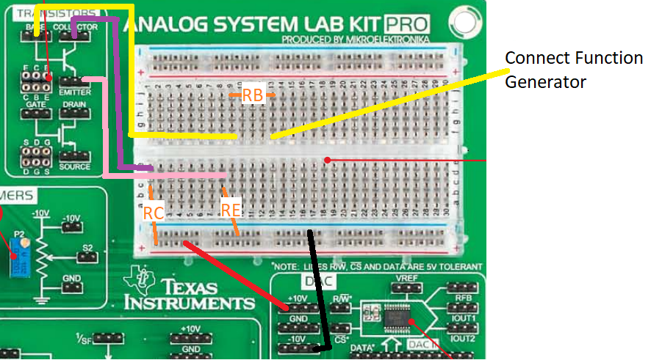**Preparation:**

Figure Common emitter amplifier.

Set up the NPN (2n3904 or model 2n5088 – pg. 81 of lab kit manual) common emitter transistor amplifier circuit on the breadboard as shown above. This is very similar to a common source amplifier for a MOSFET.

Figure Diagram of amplifier on the board.

The resistor value RC (sometimes called RL for load for different circuits) is not critical, anywhere between 10K and 50Kohms is fine. The base resistor is also not critical and is fine around 100K to 250K ohms.

You will do amplification in two modes: without RE and with it. You will also do the lab in both single and dual supply.

**Lab:**

**Part 1: NPN Transistor Amplifier**

1. First, operate the amplifier with dual supply and **without RE (directly connect emitter terminal to -10V)**. Use the function generator to input a DC voltage to the circuit, which is the Vin variable in the schematic above. Change this until you find the DC voltage that causes the DC value of Vo to be ~zero (half way between Vcc and Vee). This is the “operating point”, AKA the proper offset voltage, AKA the proper DC bias. What input value do you get?

Vin = -8.766V

1. Add an AC sinusoid input (keeping the DC Vos voltage at the bias point found above) with some amplitude and monitor the amplitude of the output on the oscilloscope to ensure that amplification is linear and inverting. If it is not, you will need to reassess the operating point.
2. Change the amplifier operation to single supply: VEE = 0. Be sure to change your reference voltages for oscilloscope and function generator from GND to -10V now.
3. Record the DC value of Vin which causes the DC value of Vo to be approximately 1/2 VCC (again, the operating point). Record the operating points at each of these 2 cases : Re = zero (without Re), and Re ~ RC/10. Then measure AC gain by changing the input to a very small sinusoidal input (very small Vpp) and an appropriate DC value (Voffset) for both cases. Make the frequency around 1k.

Write down your Re:__1k

Operating points when Re=0: 973.5mV and when Re≠0 (include Re): 1.477 V

AC Gain when Re=0 _968.5mV AC Gain when Re≠0 (include Re): 1.447V

1. Now you will check how different frequencies effect the output.

Vary the AC frequency for both cases, and record the frequency that causes Vout to decrease by 30%:

Re=0: 23kHz Re≠0 47.2kHz

1. Include pictures of your oscilloscope below for the last step, in both time (normal mode) and XY mode, only for Re≠0. Change the oscilloscope to operate in time mode and XY mode as described in the introductory pre-lab (“Horiz” ->Mode Selection Bottom Left). For XY mode to work correctly, **channel 1** must be connected to Vin **and channel 2** must be connected to Vout.

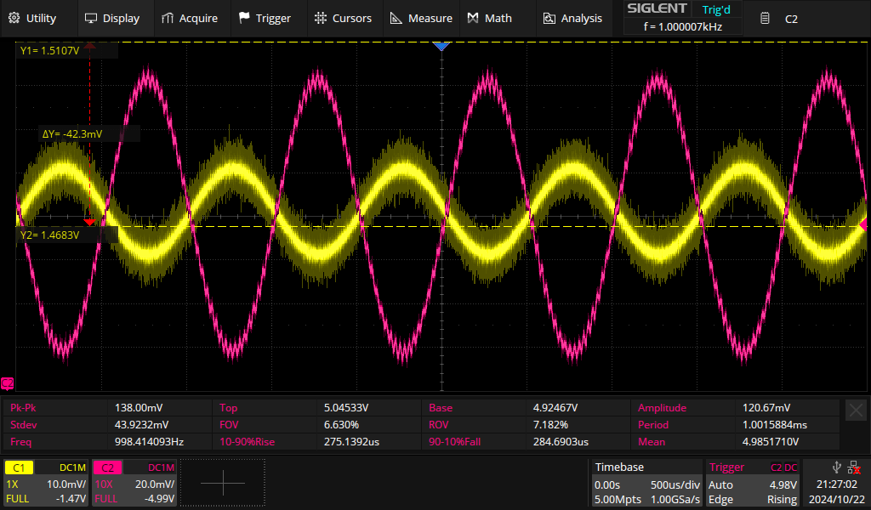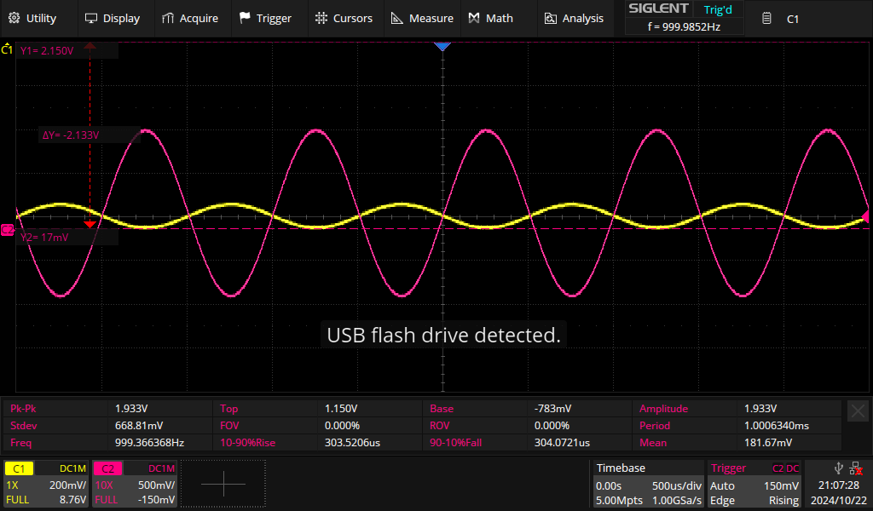

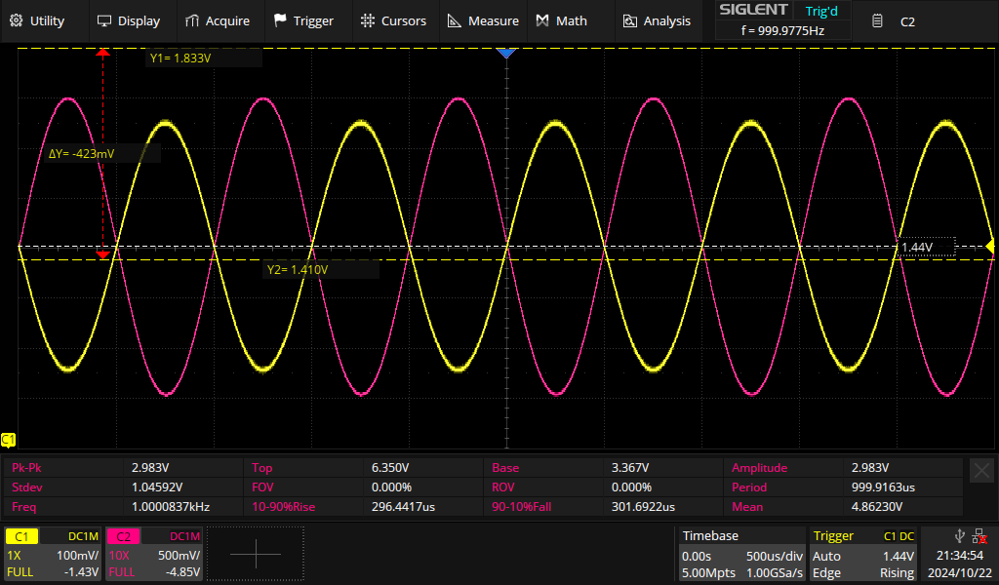

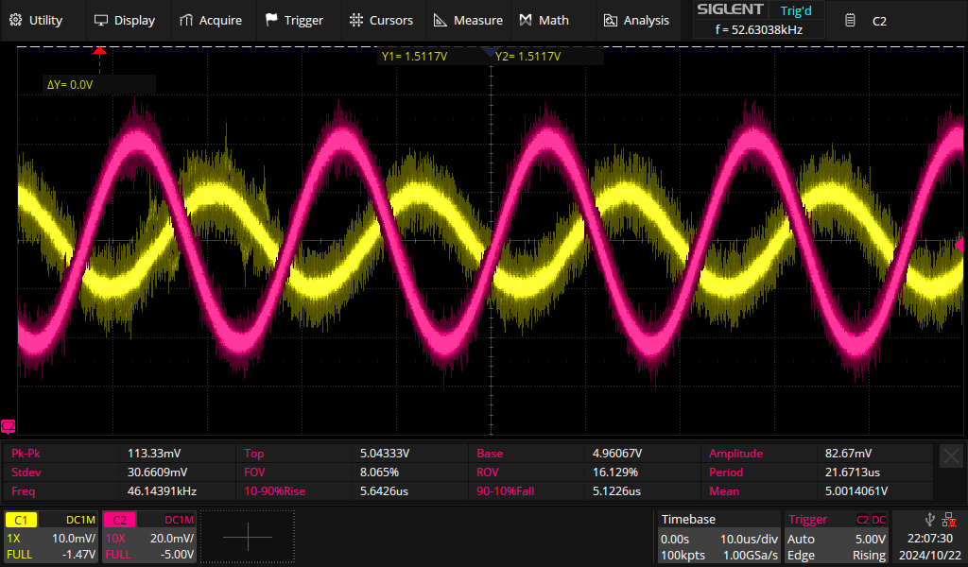

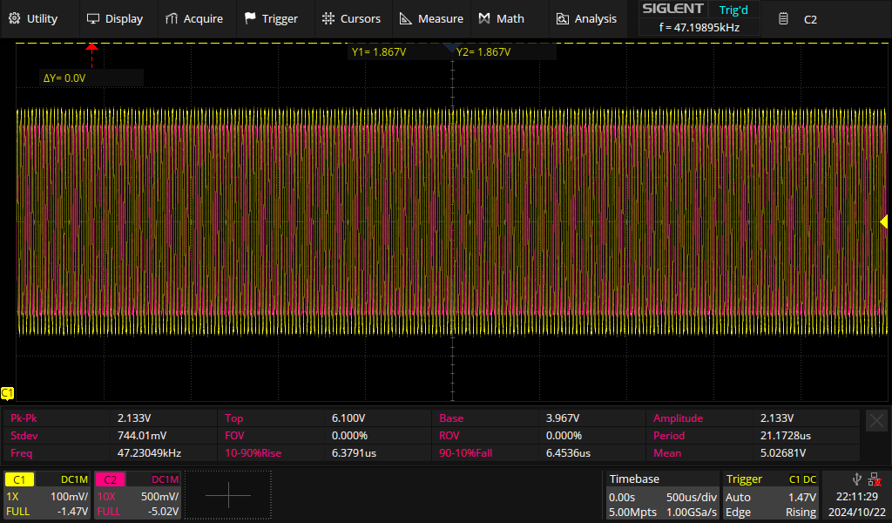

**Part 2: PNP Transistor Amplifier (**

1. Now setup the circuit using a PNP transistor (2n3906 or 2n5087, ASLK manual p. 81) in single supply using the circuit below.

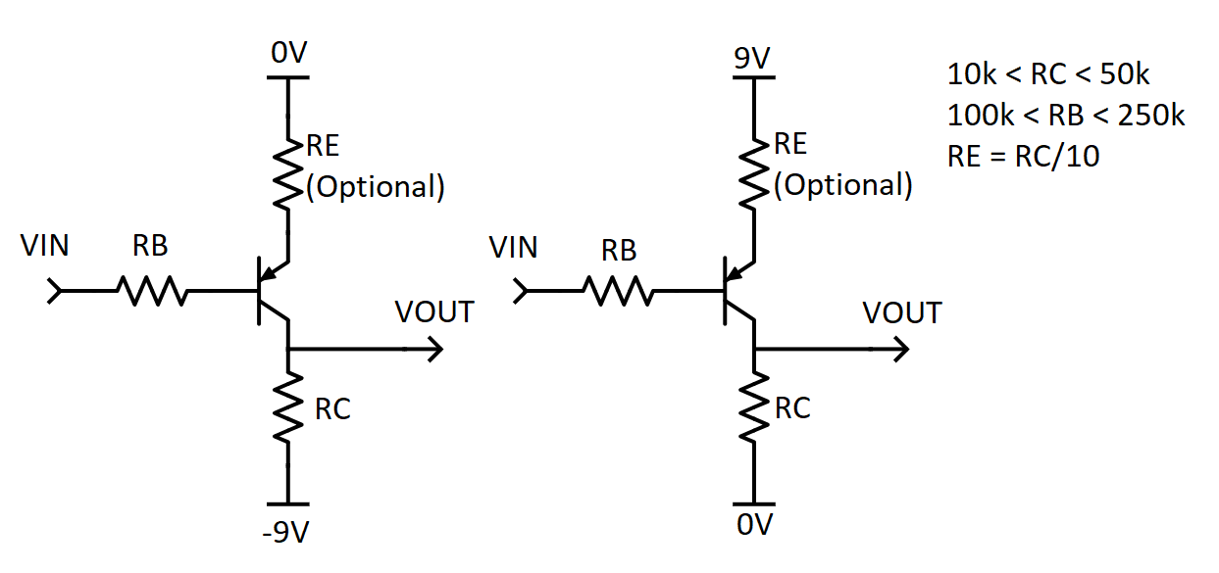

1. Record the DC value of Vin which causes the DC value of Vo to be approximately 1/2 VCC (again, the operating point). Record the operating points at each of these 2 cases : Re = zero, Re ~ RC/10. Then measure AC gain by changing the input to a very small sinusoidal input (very small Vpp) and an appropriate DC value (Voffset) for both cases. Make the frequency around 1k.

Write down your Re:_1k

Operating points when Re=0:_8.271V and when Re≠0:7.818V

AC Gain when Re=0 : 18 AC Gain when Re≠0 : 7.6

1. Vary the AC frequency for both cases, and record the frequency that causes Vout to decrease by 30%:

Re=0:19kHz Re≠0: 29kHz_

1. Include pictures of your oscilloscope below for the last step, in both time (normal mode) and XY mode, only for Re≠

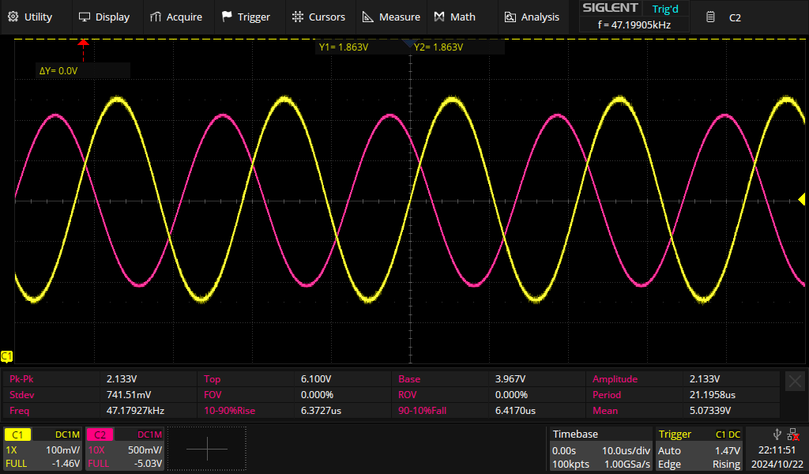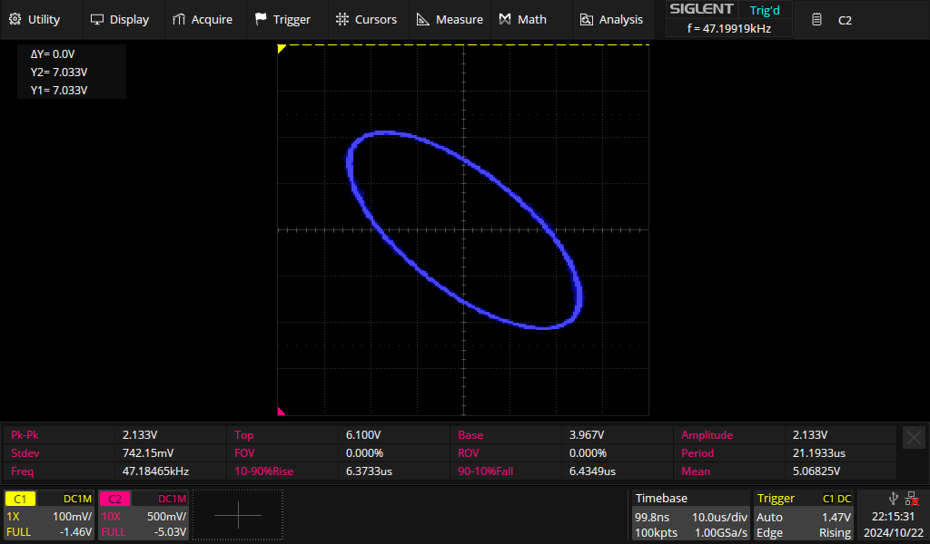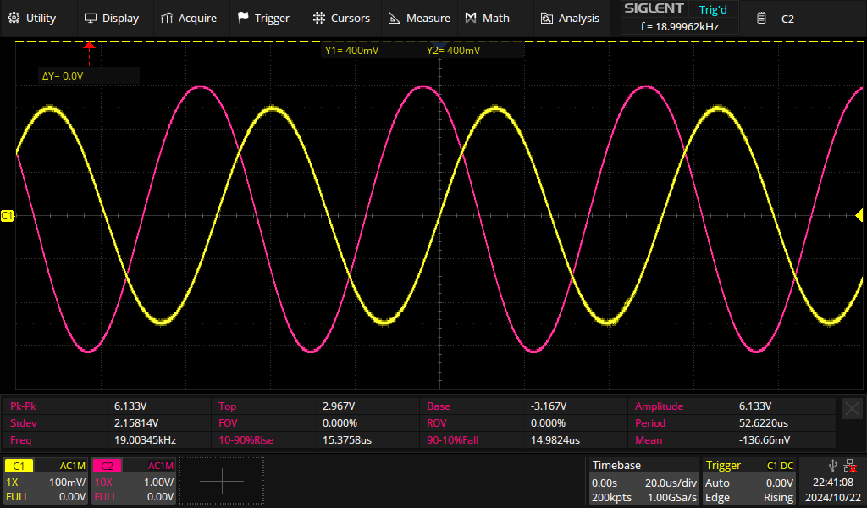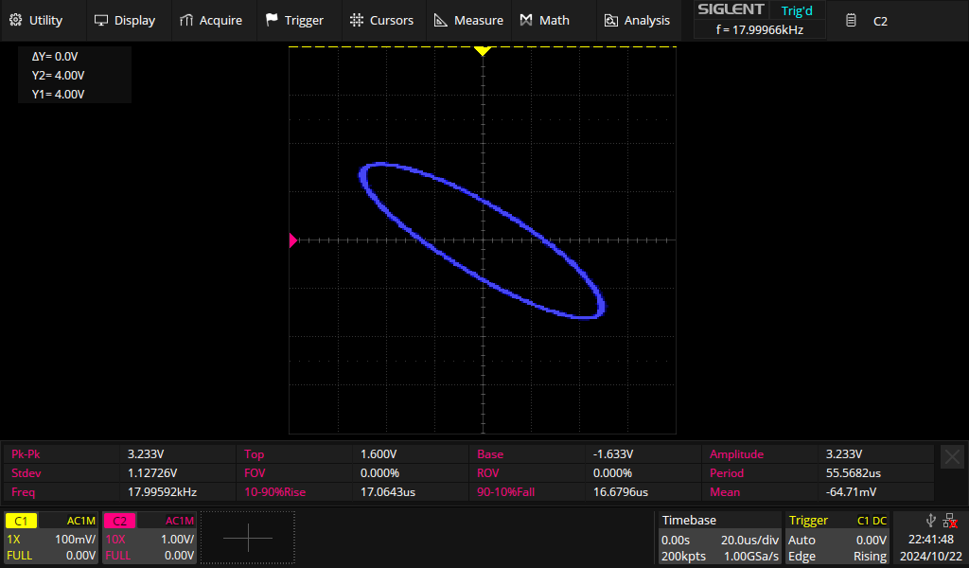

**Part 3: Non-Inverting Amplifier with Transistor Stage**

1. Open the TopSpice schematic titled “NonInvertingTransistorStage.sch”
2. Run this simulation and gain an understanding of what happens when some of the component values are changed. I would save another copy of this, such that, you have an original copy with unedited values and then your own schematic with some changes. Ask yourself what values control the output gain in the transient response plots?
3. Next, we will **build** this circuit on our TI board using the TopSpice schematic as our guide. Notice which type of transistor is being used based on the symbol, refer to the previous figures above to decide which transistor model is needed for the build. Also, note RE doesn’t have to be exactly 1k, try resistors on the order of 1-10k.
4. Include one image from the Transient analysis plot from your (potentially altered) TopSpice simulation and one oscilloscope picture with input and output curves visible with peak-peak measurements.

**Part 4: Inverting Amplifier with Transistor Stage**

1. Similarly, open the TopSpice schematic titled “InvertingTransistorStage.sch”
2. Run this simulation and gain an understanding of what happens when some of the component values are changed. Again, save another copy of this, such that, you have an original copy with unedited values and then your own schematic with some changes. What values control the output gain in the transient response plots?
3. Now build this circuit using the schematic as our guide.
4. Include one image of the transient response plot from TopSpice and one image of the oscilloscope with input and output curves visible with peak-peak measurements.

